**Space-air-ground integrated network (SAGIN),** as an integration of satellite systems, aerial networks, and terrestrial communications, has been becoming an emerging architecture and attracted intensive research interest during the past years. Besides bringing significant benefits for various practical services and applications, **SAGIN is also facing many unprecedented challenges due to its specific characteristics, such as heterogeneity, self-organization, and time-variability.** Compared to traditional ground or satellite networks, SAGIN is affected by the limited and unbalanced network resources in all three network segments, so that it is difficult to obtain the best performances for traffic delivery. Therefore, the system integration, protocol optimization, resource management, and allocation in SAGIN is of great significance.

Space-air-ground integrated network (SAGIN) has emerged as a paradigm shifting architecture that offers large-scale, flexible wireless coverage and seamless, high-rate connectivity to complement terrestrial communications.

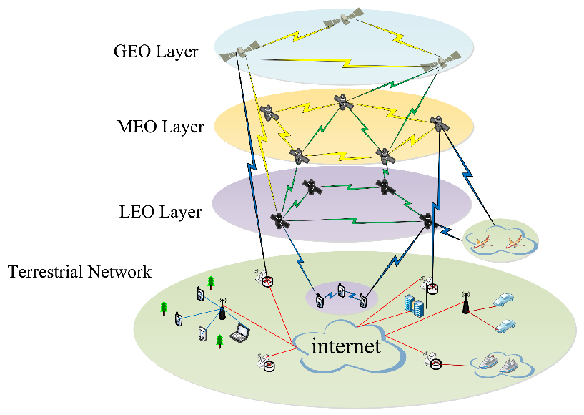

Current maritime communications rely mainly on satellites with weak transmission resources and lesser performance than modern terrestrial wireless networks. To meet heterogeneous business requirements, SAGIN framework is proposed. However, due to heterogeneity, self-organization, and time unpredictability, designing and optimizing the SAGIN framework is challenging. **The primary difficulty is designing an effective routing system that can handle a highly dynamic network architecture.**

**Recent advances in artificial intelligence have generated various routing algorithms for wireless communications, such as deep learning (DL)-assisted routing algorithms for balancing traffic in SAGINs.** However, in such routing algorithms, the network topology is assumed to be static, and routing decisions are made based on the state of the nodes in the global network. Therefore, to handle highly dynamic network topologies, the authors designed a deep reinforcement learning (DRL)-assisted routing algorithm for ad hoc aeronautical networking (AANET). The algorithm relies entirely on local information and can achieve near-optimal end-to-end delays. To meet the needs of heterogeneous services and to accommodate the dynamic nature of SAGINs, the authors further propose a DL-assisted multi-objective routing algorithm. The algorithm utilizes a quasi-predictable network topology and operates in a distributed manner. The author proposed a DL-assisted routing algorithm that minimizes end-to-end delay to aid comprehension. For single destination routing, each snapshot of the network topology can calculate link delays based on each node’s coordinates and delay model. The approach trains a single-objective deep neural network (SO-DNN) to embed network topology information. During algorithm training, all nodes’ queuing delays are constant. Then, the SO-DNN calculates the minimal delay between each source–destination pair using the shortest path technique. The authors also utilized local information to solve the multi-target routing problem for multi-target routing. Therefore, similar to SO-DNN, the algorithm uses a multi-objective deep neural network (MO-DNN) to learn. Experimental results show that the integrated network achieves better network coverage, lower latency, higher throughput, and a longer path life.

**Satellite networks** are an essential part of the space–air–ground integrated network.

**Factors affecting routing in satellite network**

The Satellite network is an important part of the global network. However, the complex architecture, changeable constellation topology, and frequent inter-satellite connection switching problems bring great challenges to the **routing designs of satellite networks**, making the study of the routing methods in satellite networks a research hotspot.

In traditional terrestrial networks, Since the topology of the terrestrial network varies less frequently, updating the routing table is no longer necessary once the network reaches a stable state. Meanwhile, the computing power and storage capacity of the router are sufficient to meet the calculation requirements of the routing table, so the existing routing protocols can be better adapted to the terrestrial network.

Compared to terrestrial networks, satellite networks can provide global coverage and efficient communication services without the constraints of geography and infrastructure. The satellite network topology is highly ***dynamic and time-varying***, and satellites have limited onboard computing and storage due to their size and power consumption. In particular, the relatively **long inter-satellite distance** and **link transmission delay** are the crucial factors affecting the routing performance of satellite networks. Additionally, terrestrial network routing algorithms are not directly applicable to satellite networks due to their high complexity and processing requirements. Therefore, it’s necessary to develop new routing algorithms depending on the characteristics of the satellite network itself.